# CS 340 README Template

## About the Project/Project Title

This project allows the user to access a database through the MongoDB Shell, and create, read, update, and delete (CRUD) entries in the database using python scripts. This allows the user the ability to change anything in a database as is necessary.

## Motivation

The primary purpose behind this program’s existence is to allow for easier management of databases through MongoDB, allowing the user to input all their changes in pre-planned python files instead of requiring the user to access the command line in order to make CRUD changes.

## Getting Started

1. Open the MongoDB Shell and import the data from a csv file
2. Create an index with the imported data
3. Access the admin console and authenticate a user associated with the index and give the user the proper permission required to read and write to the index.
4. Open up the python files and run the program through Jupyter Notebook. (You should edit the provided test file that was provided to fit your CRUD needs, and ensure the database, collection, and username/password match your database.)

## Installation

Ensure that Jupyter notebook, and the MongoDB Shell are properly installed, and set up and that the python files and MongoDB Shell are compatible.

## Usage

### Code Example

There are currently 5 functions in the code, an initialization function, and the 4 CRUD functions. The initialization function (**AnimalShelter(self, USER, PASS, HOST, PORT, DB, COL)**) is called to access the MongoDB Shell, and has 6 parameters the user must match to their pre-indexed database. The create function (**AnimalShelter.create(self, data)**) allows the user to insert a single entry into the database. The read function (**AnimalShelter.read(self, query)**) allows the user to perform a search on the database based on selected parameters, finding all entries that match the given parameters. The update function (**AnimalShelter.update(self, query, data)**) allows the user to change the data in an entry in the database. The delete function (**AnimalShelter.delete(self, data)**) allows the user to delete an entry in the database.

### Tests

An ipynb file to test the code is provided, which was prefilled to match the database I needed to test it on. The file creates a dash container for a site that allows the user to utilize a graphic user interface in order to see the database in a user-friendly manner. The table can be filtered to show only certain entries, and has 4 different pre-set filter buttons for It allows the user to click on cells in order to CRUD them, and view a pie graph of common variables between entries. It also has a map that shows the location of the selected entry.

### Screenshots

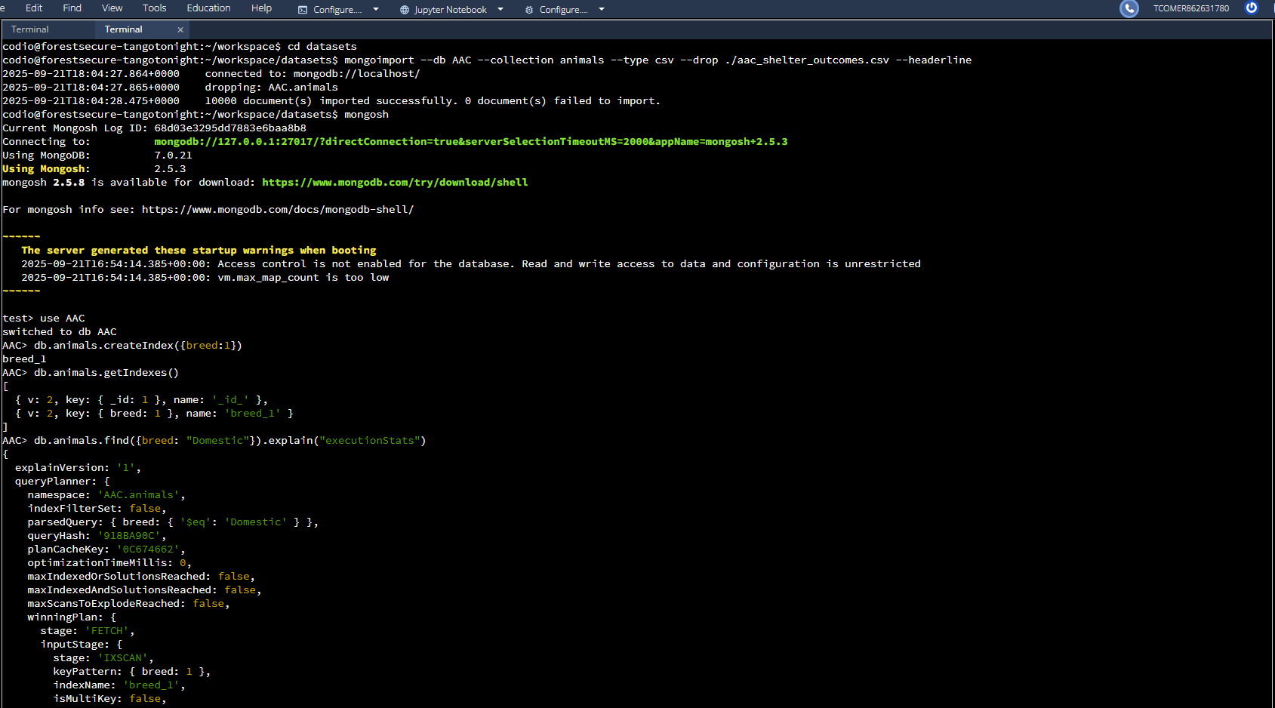  
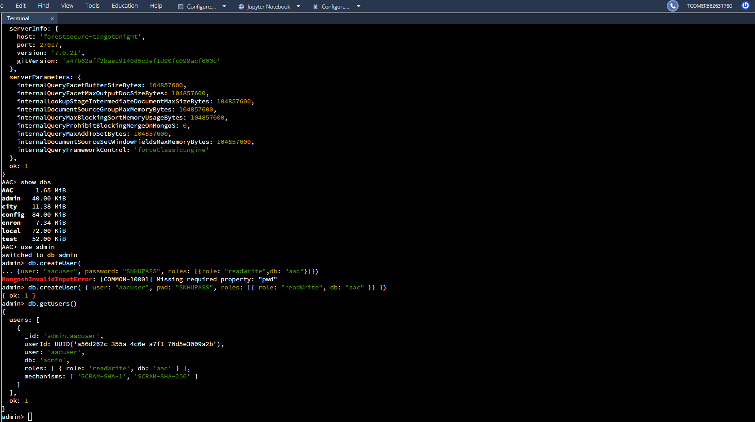

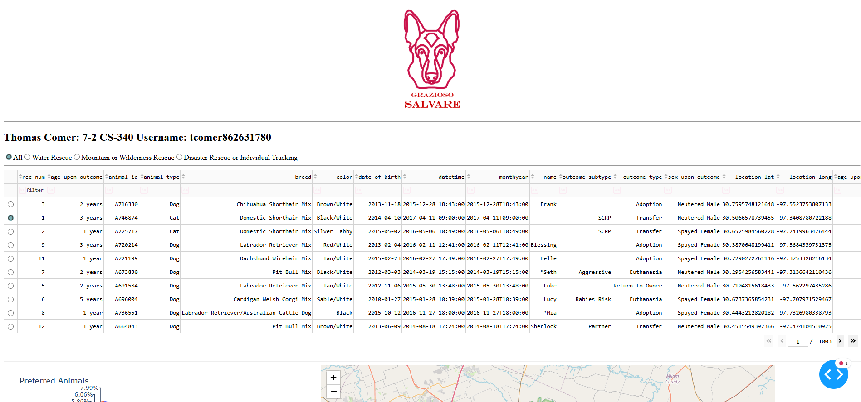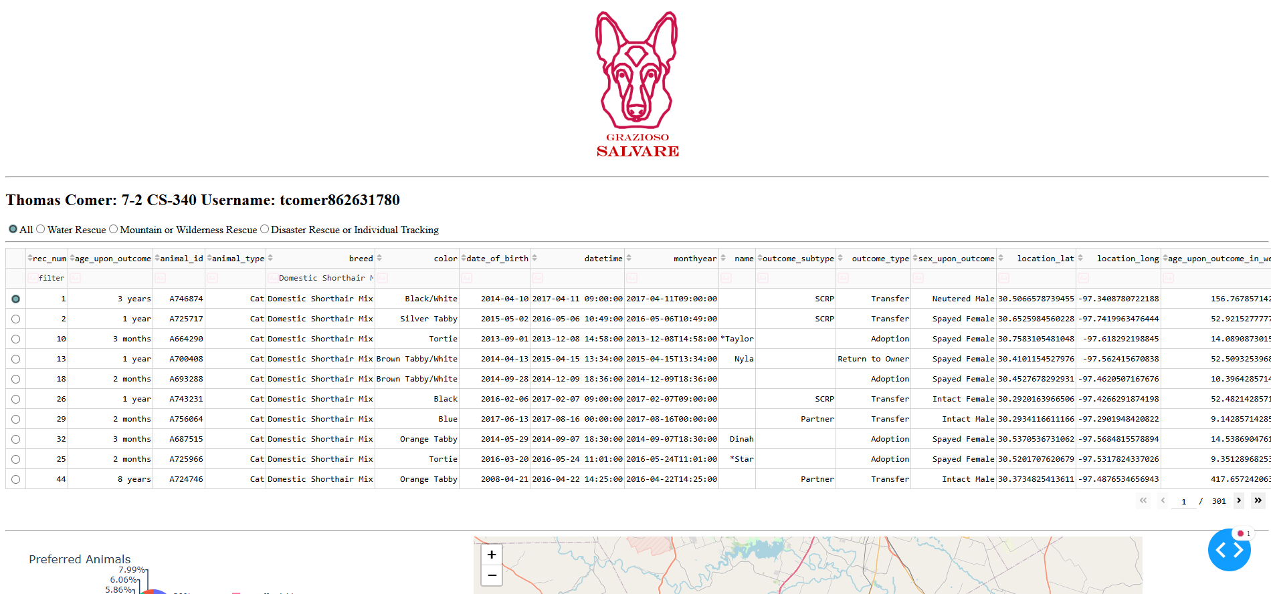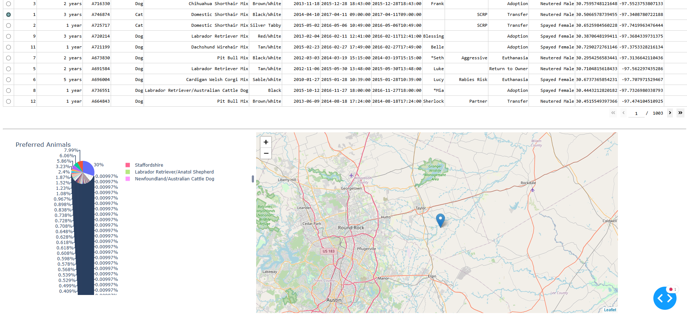

## Contact

Thomas Comer